Meeting held: **CAG Q1 = 9:00 am – 12:00** via webinar

Microsoft Teams meeting

**Join on your computer or mobile app**

[Click here to join the meeting](https://nam01.safelinks.protection.outlook.com/ap/t-59584e83/?url=https%3A%2F%2Fteams.microsoft.com%2Fl%2Fmeetup-join%2F19%253ameeting_MDIzY2YyZTUtNjZkZi00Mzg1LTkxYzQtZDMwNGFkOTBkOWRh%2540thread.v2%2F0%3Fcontext%3D%257b%2522Tid%2522%253a%2522ce6a0196-6152-4c6a-9d1d-e946c3735743%2522%252c%2522Oid%2522%253a%2522735b9ace-1d22-4a7e-963c-194077a26ea8%2522%257d&data=04%7C01%7CMonica.Cowlishaw%40cngc.com%7Cabce3a7c040045e8604208d87c50e650%7Cce6a019661524c6a9d1de946c3735743%7C0%7C0%7C637396034191563741%7CUnknown%7CTWFpbGZsb3d8eyJWIjoiMC4wLjAwMDAiLCJQIjoiV2luMzIiLCJBTiI6Ik1haWwiLCJXVCI6Mn0%3D%7C1000&sdata=A3FFmcBe4dI5dv9CE7umf%2BmxbpbPOb9DdKqQeTs%2B2EE%3D&reserved=0)

**Or call in (audio only)**

[+1 509-505-0479,,351814161#](tel:+15095050479,,351814161# )   United States, Spokane

Phone Conference ID: **351 814 161**#

#### 

#### Roll Call - led by Monica Cowlishaw (9:00)

* Amy Wheeles is available for the first portion of the meeting,
* New Commerce representative Glenn Blackmon - Chuck Murray retired

### Review meeting minutes 10/07/20 - *led by Monica Cowlishaw*

* See Q4 *CNGC_CAG Meeting Minutes 10.7.20 Final.docx*

### *CPA update- led by Monica Cowlishaw & Phillip Hensyel*

* Phase 1 completed and will be forwarded to the TAG and included in the IRP filing in February



* Phase 2 starting in January
* LoadMAP is available to CAG members through an NDA upon request

### Benchmarking prep for HB-1257 compliance

* Clean Buildings Act

### Tariff filing update

* Update to tankless water heater – We had an error in the draft sent to the CAG as it was initially entered as .93 UEF, our intention was to set it at .91 UEF when merging the tiers - LoadMAP calculations support the .91 UEF level
* The tariff is on the “no action agenda” for January 28th’s WUTC meeting
* The Washington State building code council voted on January 8 to again delay implementation of the Building Code, from February 1 to July 1, 2021. We updated the programmable thermostat offering and will update for the new home sector when code updates later this year

### *Goal Setting for 2021 & Biennial plan*

|  |  |  |  |  |
| --- | --- | --- | --- | --- |
| Targets | **Calendar Year 2021** | | | |
| *Residential* | *C/I* | *Low Income* | ***Total*** |
| 471,164 | 578,483 | 12,180 | 1,061,827 |

* Goal setting brainstorm on alternative scenarios through LoadMAP based on COVID-19 impacts to our customers and the economy
* Feasibility of updating the Goals for the C/I program to a 2-year goal starting in the Biennial Plan to align with sector and business planning cycles

### Quarter 4 update - *led by Monica Cowlishaw & Bradey Day*

* **CNGC is providing quarterly progress updates to the CAG – these numbers have not gone through a rigorous end of the year verification and reconciliation as occurs for our official annual report and are estimates. (***data pulled through December 2020***)**

#### Commercial Highlights

* The program finished 2020 saving C/I customers 266,945 therms, paying $932,034 in incentives and reaching 69% of the overall goal for 2020. While C/I programs nationwide were deeply impacted by COVID (most programs reached between 70 to 80% of goal), Washington faced some significant challenges, as most construction was not considered essential. As such, contractors were able to complete work on schools and other essential businesses more expeditiously, but other non-essential business was delayed
* Drop in forecast, results in November
* Sample outreach from December: 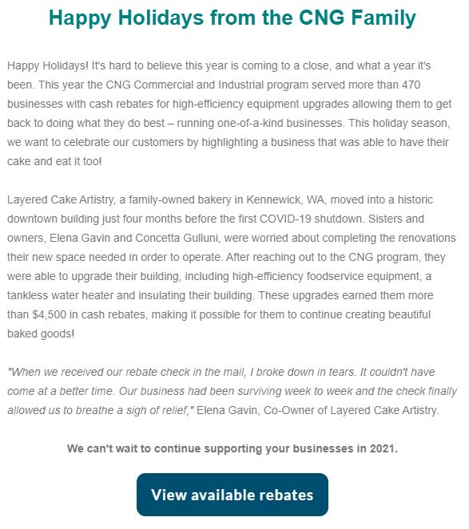

##### Commercial/Industrial Program Total & Comparison to Prior Year

|  |  |  |  |  |  |  |  |
| --- | --- | --- | --- | --- | --- | --- | --- |
| ACHIEVED |  | **2019 (%)** | **2019 Total Therms** | **2019 Total Incentive** | **2020 (%)** | **2020 Total Therms** | **2020 Total Incentive** |
| December Monthly Total |  | 1,086 | $4,000 |  | 25,082 | $79,772 |
| **YTD Total** | **104%** | **384,176** | **$939,251** | **69%** | **266,945** | **$932,034** |
| IN PROGRESS | Pre-Pipeline |  |  |  |  | 0 | $0 |
| Forecast |  | 0 | $0 |  | 0 | $0 |
| **Pre + Forecast + YTD** |  | **384,176** | **$939,251** |  | **266,945** | **$932,034** |
| Goal |  | 370,587 |  |  | 387,824 |  |
| **% to Goal** |  | **104%** |  |  | **69%** |  |

##### Commercial/Industrial Therms Achieved

##### Commercial/Industrial Therms Goal: 387,824

##### Commercial/Industrial Therms by Measure Type

#### Residential Program Highlights and Activity through December 2020

* The program saved approximately 380,883 therms, exceeded its annual therms goal by 16.2% and annualized therms grew by 5.9% compared to the 3-year average
* When factoring in energy saving kits from 2020 the EE team exceeded the residential annual goal by more than 53,000 therms
* The residential queue moving into 2021 sits at approximately 60,604 therms – which is calculated by multiplying the number of residential applications by the average therms per application year to date (107). *Note - this queue does not include builder applications*
* In December Cascade averaged 1,433 therms per day in rebate processing, maintained a weekly average of 68 paid applications with intake exceeding the 3-year average by 13%.

##### Residential Program Total & Comparison to Prior Year

|  |  |  |  |  |  |
| --- | --- | --- | --- | --- | --- |
|  |  | **3-year average Therms** | **2020 Therms** | **3-year average Incentive** | **2020 Incentive** |
| **ACHIEVED** | December Achieved Total | 26,082 | 30,098 | $102,084 | $159,153 |
| YTD Achieved Total | 359,647 | 380,883 | $1,184,941 | $2,340,205 |
| Performance-to-Plan | 358,928 | 327,801 | $2,125,269 | $3,017,205 |
| **% to Goal Achieved** | **100%** | **116%** | **56%** | **78%** |
| **IN PROGRESS** | Core Residential Queue [1] | 48,910 | 60,604 | $330,626 | $386,952 |
| Builder Queue [2] | 0 | 141,648 | $0 | $812,660 |
| **Pipeline + Queue + YTD Achieved** | 408,558 | 583,135 | $1,515,566 | $3,539,817 |
| **% to Goal in Progress** | **114%** | **178%** | **71%** | **117%** |
| [1] therms based queue volume x 2020 avg them/application de-rated for AEG CPA values | | | | |
| [2] therms based on builder applications in progress x 2019 avg them/application de-rated for AEG CPA values for new home builders. | | | | |

##### Residential Therms Achieved by Month - 2020

##### Residential Therms Goal: 327,801

##### Residential Monthly Application receipts 2017-2020

* Out of 3857 applications received 1,131 were from the builder program – equating to 29% of the total program submissions for the year
* The below figure represents the makeup of residential application submissions by month

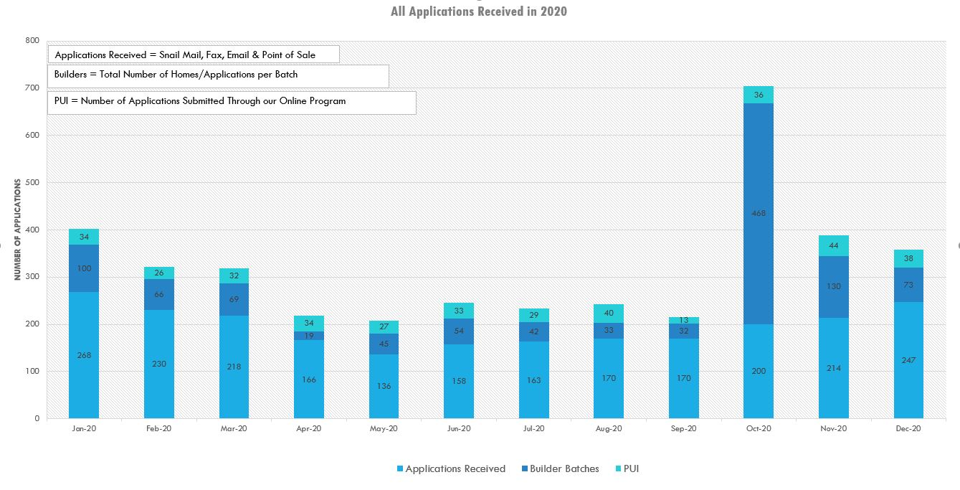

##### Annual Call log highlights

* January represents the highest numbers (382) of incoming calls, with July representing the highest total number of calls
  + This trend differs from incoming mail tracking, which peaks in the heating season (starting in October)
  + Improvements in customer communication practices via the web, mailers and ads may have had an impact to reduce incoming call volume later in 2020, or COVID-19 may have driven more customers to alternative information sources
* Pre-Application calls, meaning customers called after the install seeking direction on how to apply or if they qualify, are the most frequent calls received last year
* We see the first effects of COVID in April, when incoming calls decrease 55%
* 2020 shows a 25% decrease in incoming calls compared to 2019
* Incoming calls jumped 115% between June to July when the ESK mailer was sent

##### Residential 2020 Call Traffic

##### Incoming Calls 2019 vs 2020 Comparison

##### 2020 Status Call comparison to 2019

### C/I adaptive management plans for 2021

* Re-COV-ery
  + Overview
  + Sectors
  + Outreach
  + Market
  + Financial impact/Funding
  + Commercial Point of Sale
* Foodservice Drawing
* Financing

### Residential Point of Sale Update



### Cascade’s internal eM&V plan and timeline for 2021

### Brainstorm opportunities to work with Commerce **– introduced by Alyn Spector**

* Seeking additional EE based gas conservation solutions & technologies

### Low Income Weatherization *-* **led by Alyn Spector & Sheila McElhinney**

* Program Status – Q4 update/ End of Year – note this is an estimate and has not been vetted through the annual report review process
  + 2020 update
    - 45 projects completed
    - 177 measures
    - ~$693,000 in incentives
      * ~556,000 WIP/EWIP
      * ~$137,00 in project coordination & indirect rate
    - Average project cost ~$15,000
      * Lowest reimbursement = $348.75
      * Highest reimbursement = $40,992.3 (pending)
* Feedback on meeting held with agencies in December
  + Request for support of COVID training reimbursement/ recommendation is to reallocate $20,000 outreach funds on a first come/first serve basis
* Travel expense documentation in projects – spread across measures or line item
* Should there be a cost threshold for additional review and process for due diligence of the projects as full project costs increase under COVID safety requirements
  + What would trigger the need for additional review? 150% over average project cost, over $40,000 on a single home, etc.

### 2021 Quarterly Meeting Schedule

* Meetings are typically held from 9am – 12pm
* We may need more ad hoc meetings via email and teleconference to accommodate stakeholder feedback and participation in the CPA process during Q1 & Q2
* At this point planning virtual meetings in Q1 & Q2, the rest of the year TBD
  + Q2 April 21, 2021 - Teams
  + Q3 July 14, 2021- WUTC offices (permitting) – or Teams
  + Q4 October 13, 20201 – Bellingham or Teams

### Wrap up